# Create a Khan Academy Account - Student

For that, access <https://www.khanacademy.org/> and click on the Sign-up option that best applies to what will be your major role in Khan Academy - Learner.

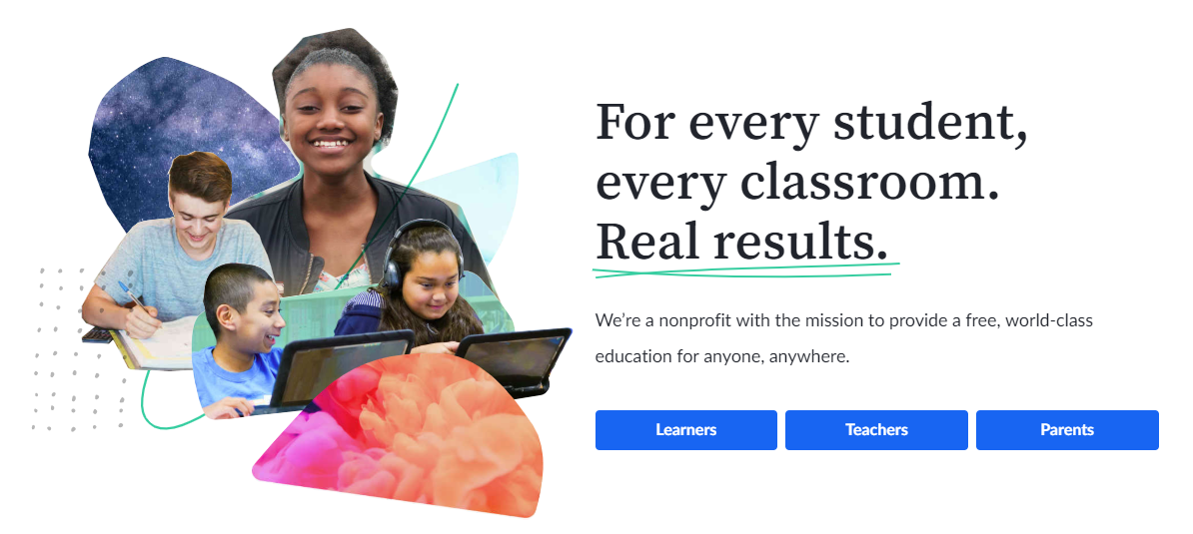

Next, choose how you'd like to sign up - Google, Facebook, Apple or Email.

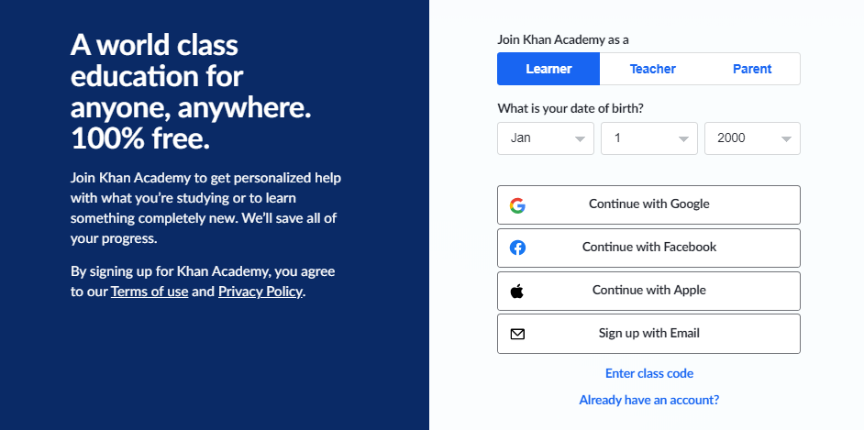

Learners younger than 13 years old do not need an email in order to have an account for [privacy reasons](https://support.khanacademy.org/hc/en-us/articles/202487460-If-my-child-is-younger-than-age-13-what-login-options-are-there-) and may simply choose a username and password directly.

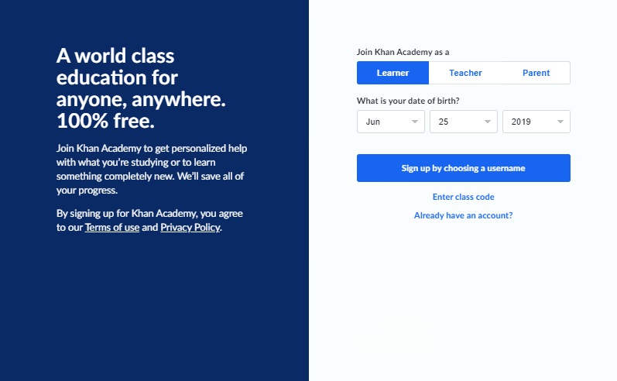

Please note that users under 13 years old will also need to include their parent's/guardian's email here so they're notified of the account created.

